**DAILY ONLINE ACTIVITIES SUMMARY**

|  |  |  |  |  |  |  |  |  |
| --- | --- | --- | --- | --- | --- | --- | --- | --- |
| **Date:** | **15/06/2020** | | | | | **Name:** | **Lavanya D M** | |
| **Sem & Sec** | **4th & ‘A’** | | | | | **USN:** | **4al18cs041** | |
| **Online Test Summary** | | | | | | | | |
| **Subject** | | **Nil** | | | | | | |
| **Max. Marks** | | **Nil** | | **Score** | | | **Nil** | |
| **Certification Course Summary** | | | | | | | | |
| **Course** | **Accettare Bitcoin nella tua azienda** | | | | | | | |
| **Certificate Provider** | | | **Bitdegree** | | **Duration** | | | **48hrs** |
| **Coding Challenges** | | | | | | | | |
| **Problem Statement:1)** Write a C Program to perform the following operations on Triply Linked List (TLL)  **2)** Write a Java Program to find if string is K-Palindrome or not | | | | | | | | |
| **Status: complied** | | | | | | | | |
| **Uploaded the report in Github** | | | | | **yes** | | | |
| **If yes Repository name** | | | | | <https://github.com/lavanyamurthi/lockdown-coding> | | | |
| **Uploaded the report in slack** | | | | | **yes** | | | |

Online Test Details: (Attach the snapshot and briefly write the report for the same)

Certification Course Details: (Attach the snapshot and briefly write the report for the same)

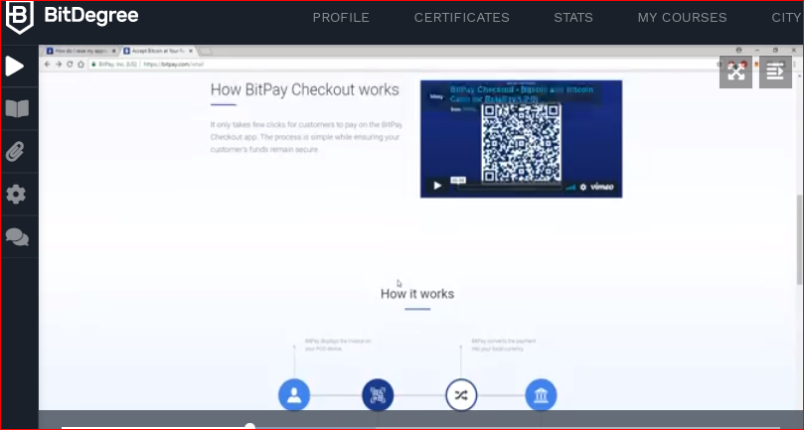

Coding Challenges Details: (Attach the snapshot and briefly write the report for the same)

Problem 1: Write a C Program to perform the following operations on Triply Linked List (TLL)

Write a C Program to perform the following operations on Triply Linked List (TLL)  
(Note that line is begins from the number 1)  
(i) Insertion at Front of the TLL  
(ii) Insertion at End of the TLL  
(iii) Insertion at front of the specified line  
(iv) Insertion at the end of the specified line  
(v) Insertion at the specified position in the specified line  
(vi) Deletion from the Front of the TLL  
(vii) Deletion from the End of the TLL  
(viii) Deletion from the front of the specified line  
(ix) Deletion from the end of the specified line  
(x) Deletion from the specified position in the specified line.  
After each operation, you should display the TLL.  
For display and Delete operation, you should take care of underflow.  
No need to check for overflow during insertion, because it is dynamic.

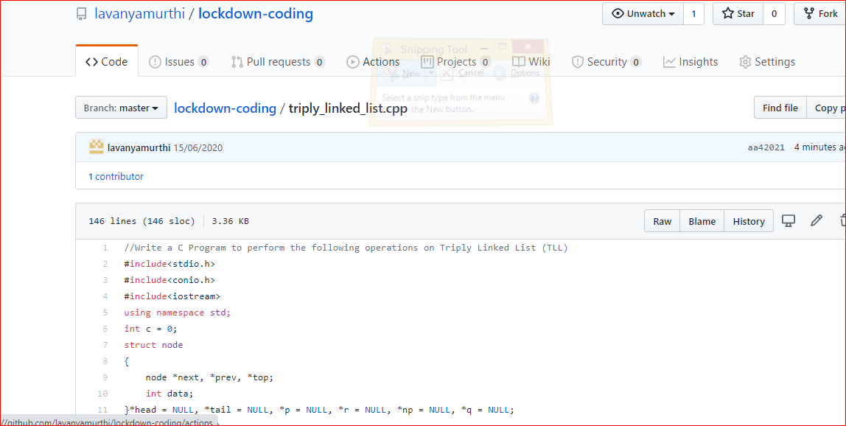

Problem 2: Write a Java Program to find if string is K-Palindrome or not

A string is k palindrome if it can be transformed into a palindrome on removing at most k characters from it. Your task is to complete the function is_k_palin which takes two arguments a string str and a number N . Your function should return true if the string is k palindrome else it should return false.

Input:  
The first line of input is an integer T denoting the number of test cases . Then T test cases follow . Each test case contains a string str and an integer N separated by space.

Output:  
The output will be 1 if the string is k palindrome else 0 .

**Example**  
Input : String - abcdecba, k = 1  
Output : Yes  
String can become palindrome by remo-  
-ving 1 character i.e. either d or e)

Input : String - abcdeca, K = 2  
Output : Yes  
Can become palindrome by removing  
2 characters b and e.

Input : String - acdcb, K = 1  
Output : No  
String can not become palindrome by  
removing only one character.

